**MERCK SEC FILINGS ANALYSIS**

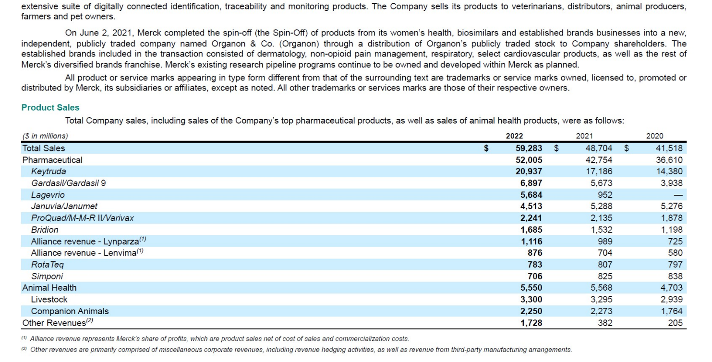**- Company’s Sales by Category:**

- U.S.-

**- Competition and the Health Care Environment:**

The markets in which the Company conducts its business and the pharmaceutical industry in general are highly competitive and highly regulated. The Company’s competitors include other worldwide research-based pharmaceutical companies, smaller research companies with more limited therapeutic focus, generic drug manufacturers, and animal health care companies. The Company’s operations may be adversely affected by generic and biosimilar competition as the Company’s products mature, as well as technological advances of competitors, industry consolidation, patents granted to competitors, competitive combination products, new products of competitors, the generic availability of competitors’ branded products, and new information from clinical trials of marketed products or post-marketing surveillance.

In addition, patent rights are increasingly being challenged by competitors, and the outcome can be highly uncertain. An adverse result in a patent dispute can preclude commercialization of products or negatively affect sales of existing products and could result in the payment of royalties or in the recognition of an impairment charge with respect to intangible assets associated with certain products. Pharmaceutical competition involves a rigorous search for technological innovations and the ability to market these innovations effectively. With its long-standing emphasis on research and development, the Company is well-positioned to compete in the search for technological innovations. The Company is active in acquiring and marketing products through external alliances, such as licensing arrangements and collaborations and has been refining its sales and marketing efforts to address changing industry conditions.

However, the introduction of new products and processes by competitors may result in price reductions and product displacements, even for products protected by patents. For example, the number of compounds available to treat a particular disease typically increases over time and can result in slowed sales growth or reduced sales for the Company’s products in that therapeutic category. The highly competitive animal health business is affected by several factors including regulatory and legislative issues, scientific and technological advances, product innovation, the quality and price of the Company’s products as well as competitors’ products, effective promotional efforts and the frequent introduction of generic products by competitors.

Global efforts toward health care cost containment continue to exert pressure on product pricing and market access. Changes to the U.S. health care system as part of health care reform enacted in prior years, as well as increased purchasing power of entities that negotiate on behalf of Medicare, Medicaid, and private sector beneficiaries, have contributed to pricing pressure. In several international markets, government-mandated pricing actions have reduced prices of generic and patented drugs. In addition, the Company’s sales performance in 2022 was negatively affected by other cost-reduction measures taken by governments and other third parties to lower health care costs. In the U.S., the Biden Administration and Congress continue to discuss legislation designed to control health care costs, including the cost of drugs. The Company anticipates all of these actions and additional actions in the future will continue to negatively affect sales and profits.

In 2022, the Company’s gross U.S. sales were reduced by 39.7% as a result of rebates, discounts and returns.

**- Legislative Changes:**

In 2022, Congress passed the Inflation Reduction Act, which makes significant changes to how drugs are covered and paid for under the Medicare program, including the creation of financial penalties for drugs whose prices rise faster than the rate of inflation, redesign of the Medicare Part D program to require manufacturers to bear more of the liability for certain drug benefits, and government price-setting for certain Medicare Part D drugs, starting in 2026, and Medicare Part B drugs starting in 2028. The long-term implications of the Inflation Reduction Act remain uncertain and subject to various factors, including the manner in which U.S. Department of Health and Human Services decides to implement the statute. Many experts and analysts, both within the industry and outside, have predicted that the law will harm innovation in the pharmaceutical industry and result in fewer new treatments being developed and approved over time. Merck is working to mitigate the potentially harmful effects that the law could have on innovation.

The Company also faces increasing pricing pressure in the states, which are looking to exert greater influence over the price of prescription drugs. A number of states have passed pharmaceutical price and cost transparency laws

The pharmaceutical industry also could be considered a potential source of savings via other legislative and administrative proposals that have been debated but not enacted. These types of revenue generating or cost saving proposals include additional direct price controls.

- EUROPE -

* Intense action toward health care cost containment
  + Reference pricing: Reference pricing may either compare a product’s prices in other markets (external reference pricing) or compare a product’s price with those of other products in a national class (internal reference pricing). The authorities then use the price data to set new local prices for brand-name drugs, including the Company’s drugs.
  + HTA: Some EU Member States may require the completion of additional studies that compare the cost-effectiveness of a particular product candidate to already available therapies or so-called health technology assessments (HTA), in order to obtain reimbursement or pricing approval. The HTA process, which is governed by the national laws of these countries, involves the assessment of the cost-effectiveness, public health impact, therapeutic impact and/or the economic and social impact of use of a given pharmaceutical product in the national health care system of the individual country in which it is conducted. Ultimately, HTA measures the added value of a new health technology compared to existing ones.

- JAPAN -

* Pharmaceutical industry subjected to government-mandated annual price reductions.

- CHINA -

* The Chinese government has introduced and implemented a number of structural reforms to accelerate the shift to innovative products and reduce costs. Since 2017, there have been multiple new policies introduced by the government to improve access to new innovation, reduce the complexity of regulatory filings, and accelerate the review and approval process. This has led to a significant increase in the number of new products being approved each year.
* Thus, growth in China is increasing quickly and Chinese market is becoming increasingly important.
* However, regulations for price reductions.

- EMERGING MARKETS -

* Beyond pricing and market access challenges, other conditions in emerging market countries can affect the Company’s efforts to continue to grow in these markets, including potential political instability, changes in trade sanctions and embargoes, significant currency fluctuation and controls, financial crises, limited or changing availability of funding for health care, credit worthiness of health care partners, such as hospitals, and other developments that may adversely impact the business environment for the Company.

**- Distribution:**

The Company sells its human health pharmaceutical products primarily to drug wholesalers and retailers, hospitals, government agencies and managed health care providers, such as health maintenance organizations, PBMs and other institutions. Human health vaccines are sold primarily to physicians, wholesalers, physician distributors and government entities. The Company’s professional representatives communicate the effectiveness, safety and value of the Company’s pharmaceutical and vaccine products to health care professionals in private practice, group practices, hospitals and managed care organizations. The Company sells its animal health products to veterinarians, distributors, animal producers, farmers and pet owners.

**- R&D:**

The Company’s business is characterized by the introduction of new products or new uses for existing products through a strong research and development program. On December 31, 2022, approximately 19,200 people were employed in the Company’s research activities. The Company prioritizes its research and development efforts and focuses on candidates that it believes represent breakthrough science for unmet medical needs that will make a difference for patients and payers.

**- Human Capital:**

As of December 31, 2022, the Company had approximately 69,000 employees worldwide, with approximately 28,000 employed in the U.S., including Puerto Rico, and, additionally, approximately 15,000 (Third party contractors include the Company’s temporary workers, independent contractors, and freelancers who are viewed as full-time equivalent employees. They exclude outsourced service providers) third-party contractors globally. Approximately 67,000 of the Company’s employees are full-time employees.

* Composition of Workforce:

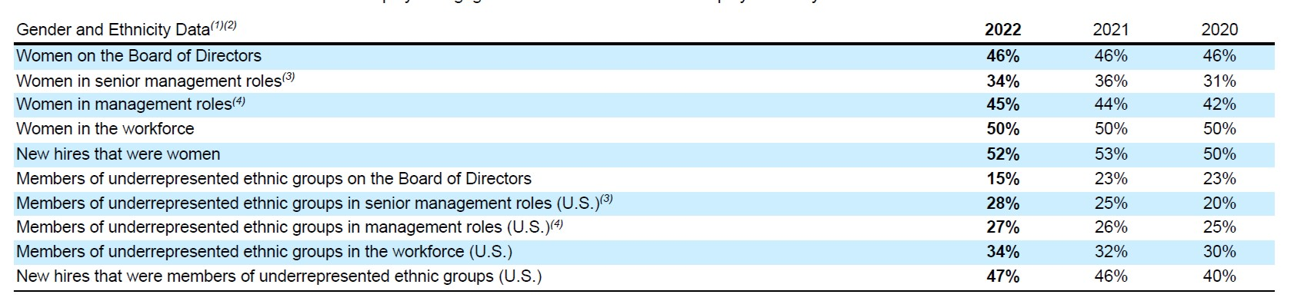

**- Sustainability:**

In 2021, the Company’s Scope 1, 2 and 3, reduction targets were verified by the Science-Based Targets initiative (SBTi). The Company has made progress toward its climate goals and aspires to meet and exceed the evolving expectations of its stakeholders and employees. These goals include achieving carbon neutrality for greenhouse gas emissions across operations (Scopes 1 and 2) by 2025, reducing Scope 1 and 2 operational greenhouse gas emissions 46% by 2030 (from a 2019 baseline), reducing Scope 3 greenhouse gas emissions by 30% by 2030 (from a 2019 baseline), and sourcing 100% of its purchased electricity from renewables by 2025.

The Company believes that there are no compliance issues associated with applicable environmental laws and regulations that would have a material adverse effect on the Company. The Company is also remediating environmental contamination resulting from past industrial activity at certain of its sites. Expenditures for remediation and environmental liabilities were $4 million in 2022 and are estimated to be $23 million in the aggregate for the years 2023 through 2027.

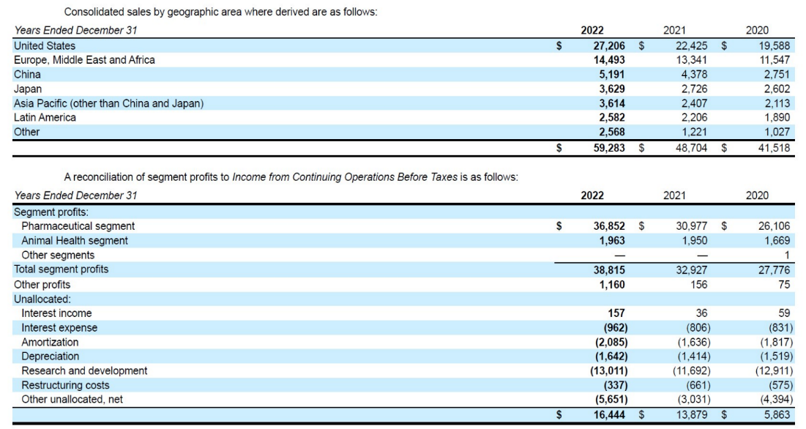**- Sales by Region and Segment:**

The Company’s operations outside the U.S. are conducted primarily through its more than 200 subsidiaries. Sales worldwide by subsidiaries outside the U.S. as a percentage of total Company sales was 54% in both 2022 and 2021 and 53% in 2020.

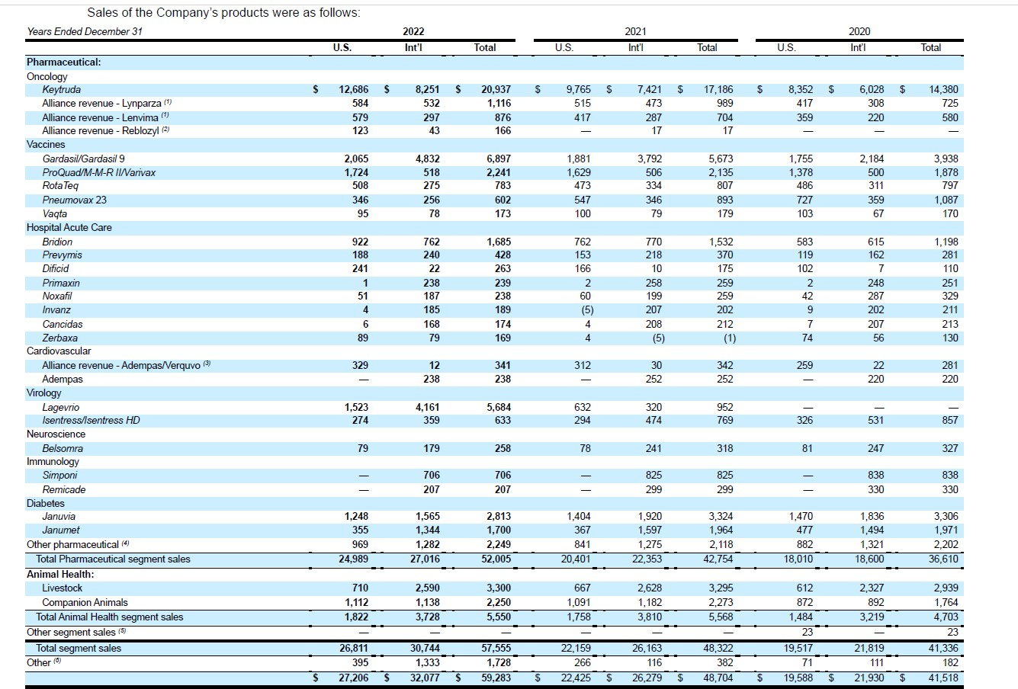**- Sales of the Company’s Products:**

**- Performance Graph:**

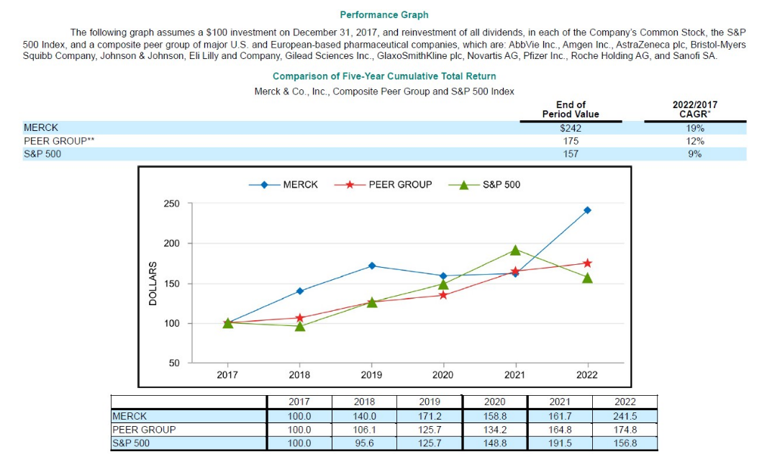

**- RISK FACTORS -**

The Company is subject to a number of risks that if realized could materially adversely affect its business, results of operations, cash flow, financial condition or

prospects. The following is a summary of the principal risk factors facing the Company:

• The Company is dependent on its patent rights, and if its patent rights are invalidated or circumvented, its business could be materially adversely affected.

• As the Company’s products lose market exclusivity, the Company generally experiences a significant and rapid loss of sales from those products.

• Key products generate a significant amount of the Company’s profits and cash flows, and any events that adversely affect the markets for its leading products could have a material adverse effect on the Company’s results of operations and financial condition. The Company expects that sales of Lagevrio, which were $5.7 billion in 2022, will decline significantly to approximately $1.0 billion in 2023.

• The Company’s research and development efforts may not succeed in developing commercially successful products and the Company may not be able to acquire commercially successful products in other ways; in consequence, the Company may not be able to replace sales of successful products that lose patent protection.

• The Company’s success is dependent on the successful development and marketing of new products, which are subject to substantial risks.

• The Company faces continued pricing pressure with respect to its products.

• Unfavorable or uncertain economic conditions, together with cost-reduction measures being taken by certain governments, could negatively affect the Company’s operating results.

• The Company faces intense competition from lower cost generic products.

• The Company faces intense competition from competitors’ products.

• COVID-19-related disruptions have had an adverse impact on the Company’s business, operations and financial performance. The Company is unable to predict the full extent to which the COVID-19 pandemic or any future pandemic, epidemic or similar public health threat will adversely impact its business, operations, financial performance, results of operations, and financial condition.

• The Company has significant global operations, which expose it to additional risks, and any adverse event could have a material adverse effect on the Company’s results of operations and financial condition.

• Climate change or legal, regulatory or market measures to address climate change may negatively affect the Company’s business, results of operations, cash flows and prospects.

• Environmental, social and governance (ESG) matters may impact the Company’s business and reputation. Changes in tax laws including changes related to the taxation of foreign earnings. Changes in accounting pronouncements that can be adverse to the company.

• Failure to attract and retain highly qualified personnel could affect the Company’s ability to successfully develop and commercialize products.

• The Company may experience difficulties and delays in manufacturing certain of its products, including vaccines.

• The Company may not be able to realize the expected benefits of its investments in emerging markets.

• The ongoing war between Russia and Ukraine and related global disruptions could adversely affect the Company’s business, results of operations and financial condition.

• The Company is exposed to market risk from fluctuations in currency exchange rates and interest rates.

• Pharmaceutical products can develop unexpected safety or efficacy concerns.

• Reliance on third-party relationships and outsourcing arrangements could materially adversely affect the Company’s business.

• Negative events in the animal health industry could have a material adverse effect on future results of operations and financial condition.

• Biologics and vaccines carry unique risks and uncertainties, which could have a material adverse effect on the Company’s future results of operations and financial condition.

• The health care industry in the U.S. has been, and will continue to be, subject to increasing regulation and political action.

• The Company’s products, including products in development, cannot be marketed unless the Company obtains and maintains regulatory approval.

• Developments following regulatory approval may adversely affect sales of the Company’s products. Efficacy or safety concerns with respect to marketed products, whether or not scientifically justified, leading to product recalls, withdrawals or declining sales.

• The Company is subject to a variety of U.S. and international laws and regulations.

• The Company is subject to evolving and complex tax laws, which may result in additional liabilities that may affect results of operations and financial condition.

• Adverse outcomes in current or future legal matters could negatively affect Merck’s business.

• Product liability insurance for products may be limited, cost prohibitive or unavailable.

•The Company is increasingly dependent on sophisticated software applications and computing infrastructure. The Company could be a target of future cyber-attacks that could lead to a disruption of its worldwide operations, including manufacturing, research and sales operations.

• Social media and mobile messaging platforms present risks and challenges.

**- Company’s Overview:**

The company was founded in 1891 originally as the American affiliate of the German Merck Group. However, 80% of the company’s shares were expropriated by the American government in WWI (Trading with the Enemy Act of 1917). Since then, the company has remained a separate entity. It is headquartered in Rahway, New Jersey.

Merck & Co., Inc. (Merck or the Company) is a global health care company that delivers innovative health solutions through its prescription medicines, including biologic therapies, vaccines and animal health products. The Company’s operations are principally managed on a product basis and include two operating segments, Pharmaceutical and Animal Health, both of which are reportable segments.

The Pharmaceutical segment includes human health pharmaceutical and vaccine products. Human health pharmaceutical products consist of therapeutic and preventive agents, generally sold by prescription, for the treatment of human disorders. The Company sells these human health pharmaceutical products primarily to drug wholesalers and retailers, hospitals, government agencies and managed health care providers such as health maintenance organizations, pharmacy benefit managers and other institutions. Human health vaccine products consist of preventive pediatric, adolescent and adult vaccines. The Company sells these human health vaccines primarily to physicians, wholesalers, physician distributors and government entities.

The Animal Health segment discovers, develops, manufactures and markets a wide range of veterinary pharmaceutical and vaccine products, as well as health management solutions and services, for the prevention, treatment and control of disease in all major livestock and companion animal species. The Company also offers an extensive suite of digitally connected identification, traceability and monitoring products. The Company sells its products to veterinarians, distributors, animal producers, farmers and pet owners.

Merck has collaborations with AstraZeneca, Bayer, Eisai Co, Ridgeback Biotherapeutics and Gilead Sciences to jointly develop and commercialize long-acting treatments.